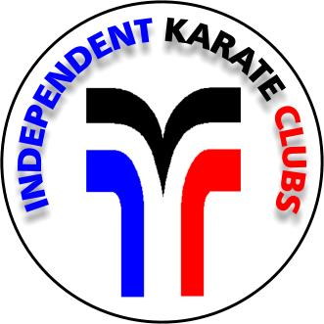
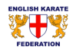Welcome To
Independent Karate Clubs

Independent Karate Clubs are run by
Qualified Instructors
Members of the English Karate Federation (EKF)

IKC instructors have many years of experience in Karate and the martial arts. We have World, European, British and English Karate champions amongst our membership.

Karate will probably be completely different from anything you may have done or tried before! It can be very enjoyable and beneficial in many aspects of life.

You are not required to be fit to start as Karate training is designed to help you gain fitness and flexibility. Disability does not exclude you from IKC. You will be given advice and training to succeed in becoming fit or fitter. You will require loose fitting clothing to start. i.e. tracksuit , jogging bottoms & tee shirt. Once you decide to continue training, you can obtain the correct clothing and equipment from your instructors. (Price list below)

After 3 lessons you will be required to apply for a licence. This is a ruling by the EKF and is a registration with them. You must do this so that you can grade and progress to the next level and if you want to, take part in competitions. Your licence will be recognised worldwide should you ever wish to train or compete abroad.

Equipment Price List *Both colours required for competitions
Equipment  *Karate suit price includes embroidered IKC badge |  | Details | Price
Karate Gi – Junior * | 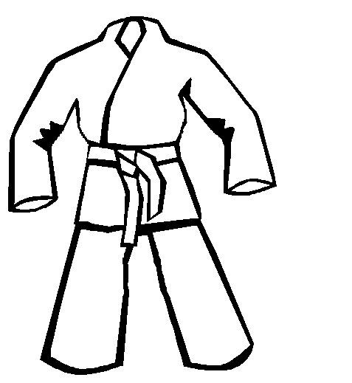   | Up to size 2 | £ 25.00
Karate Gi – Senior * |  | Size 3 to 7 | £ 30.00
Karate Belt | 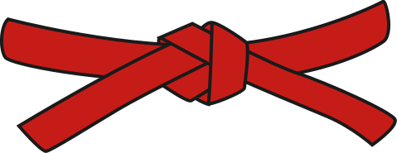 | All sizes | £6.00
IKC Tee Shirts | 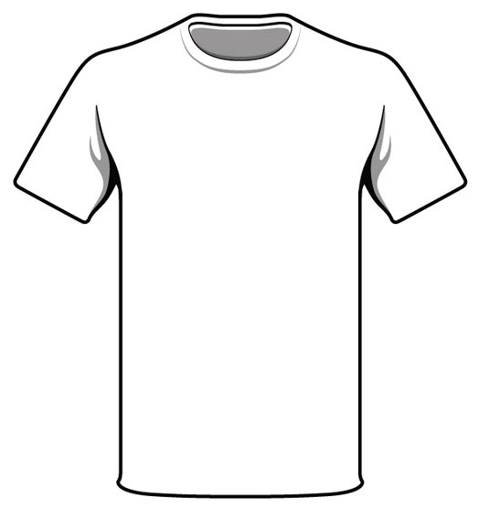  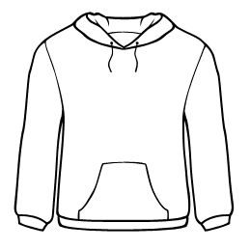 | All sizes - From | £9.00
IKC Sweat Top |  | All sizes - From | £15.00
IKC Cap | 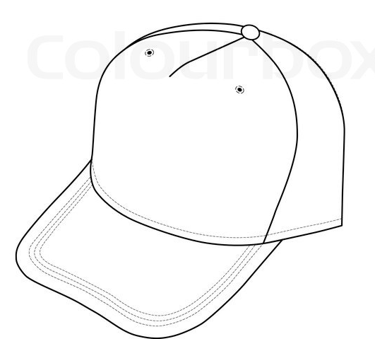  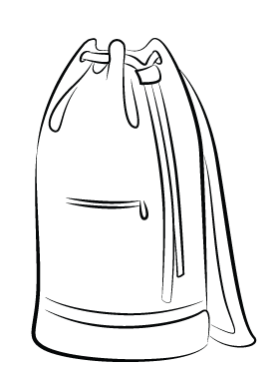 | All sizes - From | £11.50
Karate Kit Bag |  | Colours: Red, Blue  (Includes Name embroidered) | £14.50
Hand Pads | 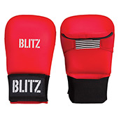 | One Red ‘or’ Blue pair  *Both One Red & One Blue pair | £17.00  £30.00*
Leg Pads (Shin and Instep) | 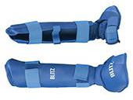 | One Red ‘or’ Blue pair  *Both One Red & One Blue pair | £37.00  £68.00*
Hand & Leg Pads |  | A Red or Blue set | £48.00
Gum Shield | 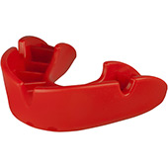 | From | £2.00
Set (Bag, Hand Pads, Gum Shield) |  | Red or Blue Set | £30.00
Set (Bag, Hand Pads, Leg Pads, Gum Shield) |  | Red or Blue Set | £65.00
IKC Welcome June 2016
EQUIPMENT ORDER
Independent Karate Clubs

Please select the number of items you wish to purchase in the ‘Qnty’ column and ‘Total’ cost.
At the very bottom, complete the ‘Final Total’.

Complete your personal details below, and hand this order to your instructor along with payment (Cash or Cheques – made payable to IKC)

*Both colours required for competitions
Equipment  *Karate suit price includes embroidered IKC badge |  | Details | Size /  Colour | Price | Qnty | Total
Karate Gi – Junior * |  | Up to size 2 |  | £ 25.00
Karate Gi – Senior * |  | Size 3 to 7 |  | £ 30.00
Karate Belt |  | All sizes |  | £6.00
IKC Tee Shirts |  | All sizes - From |  | £9.00
IKC Sweat Top |  | All sizes - From |  | £15.00
IKC Cap |  | All sizes - From |  | £11.50
Karate Duffle Bag |  | State: Red or Blue  & Embroidered Name |  | £14.50
Hand Pads |  | One Red ‘or’ Blue pair  *Both One Red & One Blue pair |  | £17.00  £30.00*
Leg Pads (Shin and Instep) |  | One Red ‘or’ Blue pair  *Both One Red & One Blue pair |  | £37.00  £68.00*
Hand & Leg Pads |  | A Red or Blue set |  | £48.00
Gum Shield |  | From |  | £2.00
Set (Bag, Hand Pads, Gum Shield) |  | Red or Blue Set |  | £30.00
Set (Bag, Hand Pads, Leg Pads, Gum Shield) |  | Red or Blue Set |  | £65.00
Personal Details IKC Welcome June 2016 |  |  |  | Final Total
Ordered by/Student Name: ^{Circle appropriate:} [TO PAY] [PAID £] Cash/Card/Chq

Contact phone No.: Goods Ordered Goods Taken
Email: Date: Notes:

RECEIPT

Received, with thanks, the sum of £ Cash/Cheque for equipment

Date: Instructor:
Independent Karate Clubs Tel: 07590 687477 Email: admin@ikc.org.uk

